ME 335: Fluid Flow

Lab 4 Report: Linear Momentum
10, April 2021

Section 6
Group 2

The following represents the original work of

Student 1, Michael White


ABSTRACT

In this lab report, a water jet from a nozzle is used to apply a force on a plate, which directs the ideally vertical flow into horizontal flow. This force on the plate affects the transducer force shown, which is used in comparison with the theoretical force from the flow rates used in the water jet. The theoretical force and the measured transducer forces (adjusted for the force at the plate) are derived from the linear momentum equation. After data collection and analysis, the two force data sets seemed to trend well together, though the transducer forces were consistently higher than the theoretical values. Potential error for this shift was speculated via the shift applied in the adjustment of the transducer forces, highlighting plate weight as a potential source of error. When attempting to adjust for this slightly, the force data sets matched up exceptionally well. In either case, the data trends validate the concept of conservation of linear momentum through relating both sides of the associated equation.
- INTRODUCTION
In this lab, the concept explored is the conservation of linear momentum. This concept is used to determine the theoretical force that should be experienced via the flow rate of a jet of water impacting a plate. Ideally, the momentum of the water jet is directed entirely to the horizontal plane, resulting in an upward force on the plate to maintain the vertical linear momentum. So, if momentum is conserved and the calculations are accurate, they should match up closely with the force measurements from the transducer adjusted to measure the impingement force.
The considerations in this analysis have several different applications. The flow force analysis could be applied to tools such as pressure washers. Given that this system involves a perpendicular application of force, the linear momentum in the horizontal direction is ideally remaining at zero if the fluid is spread out evenly in all horizontal directions. So, this analysis could be applied directly to perpendicular pressure wash application. In addition, potential error in this experiment could arise if the momentum of the water is not directed evenly in all directions, which is unlikely to occur anyway. However, analysis of this error could be compared to a pressure washer being used at an angle, which affects the applied horizontal force component.
A similar, simulated experiment was completed by Saeed R. Yassen at the University-Erbil in Iraq [1]. They compared the results of completing this analysis with a flat plate and a hemispherical plate. This showed that the hemispherical plate absorbed more energy (producing more force applied) because the water continues to apply energy to the system through its transition to the horizontal direction. Comparing this to this lab, the result should be somewhat like the hemispherical plate because of the gradual transition used at the center of the “flat plate” in this lab. However, there could be still some difference given that the water is not redirected back towards the origin of the water jet, like with the hemispherical plate.
Considering the ideal case of this lab, the experiment provided, and the consideration of linear momentum, it is suspected that the theoretical impingement forces from the flows will match up closely with the forces measured via the transducer, and that any potential error should generally decrease with increases in flow rate. This is due to their being less potential for momentum in the horizontal direction when the flow rates are higher, and the jet impacts the plate in full.
- MATERIALS AND METHODS
  - Experimental Setup
In this experiment, a transducer, or load cell, measures the downward force applied to it. This, in fact, means the weight of the plate is considered a positive load from the readout. This should be kept in mind for future calculations.
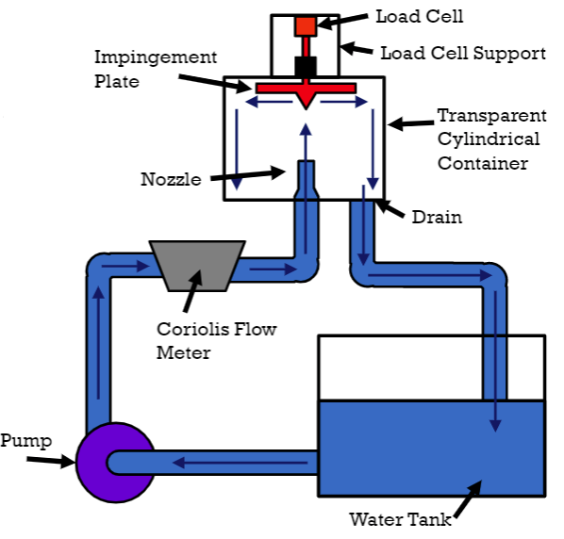
Figure 1. Streamline Flow [2]
The impingement plate is impacted with a water jet from a nozzle situated below it. Ideally, this water is all redirected into the horizontal direction, meaning the vertical, linear momentum is transferred to the impingement plate, as seen in the figure above. A Coriolis flow meter measures the flow rate of fluid entering the system via the nozzle, permitting the theoretical calculations of force applied at the nozzle. The main region of concern involving the nozzle and the impingement plate is contained in a transparent cylinder, which permits viewing of the testing to notice any unusual behaviors. For this lab, the nozzle diameter used was 0.53 inches, the mass of the plate is supposedly 0.6028 kg, and the height from the nozzle to the plate is 4.860 inches. At the time of testing, the room atmospheric pressure was 748 in. Hg with a temperature of 21.7°C. The density of water at this temperature is known to be 997.83 kg/m³.
Ten data points will be taken at each flow setting, and the average force readout and flow will be compiled for analysis. In addition to the five flow settings of 20%, 40%, 60%, 80% and 100%, readings will be taken when the flow is entirely off before and after the experiment, and one reading attempting to zero the transducer reading will be taken.
  - Analysis
To start off the equations used in this lab, the first should clearly be the conservation of linear momentum equation, obtained from Iowa State University’s “Lab 4 Linear Momentum Video Slides” [2]:
$\sum{F_{CV}}=\frac{∂}{∂t}\left(\int_{CV}^{ }{\vec{V}ρδV}\right)+\int_{CS}^{ }{\vec{V}ρ\vec{V}*\hat{n}dA}$ (1)
In this equation, the first term on the right side can simply be ignored since the momentum in the system should not be changing for a given setting. The other term is later simplified below into Eqn. 4. Once the flow rates are initially obtained, the velocity at the nozzle must be found for each flow rate. This involves the equation relating flow rate and fluid velocity via area:
$Q=V*A$ (2)
To solve for velocity, this equation can simply be rewritten as the following:
$V=\frac{Q}{A}$ (3)
After velocity is obtained, this velocity must be applied to identify the force at the nozzle. This is done through the following equation, which is derived from the second term in the Eqn. 1:
$F_{Nozzle}=V^{2}ρA$ (4)
Looking at Eqn. 1 again, this can be rewritten with Eqn. 4 with the forces written out for the control volume force sum, and rearranged to be equivalent to the force at the plate:
$-(F_{cell}-W_{plate})=V^{2}ρA-W_{water}$ (5)
For this equation, the left side is solved by reducing the transducer reading by the weight of the plate since the zero-flow readings will produce a positive value, the positive value supposedly being the weight of the plate. Shifting this value by the weight of the plate will set the scale to zero being no force applied to the plate. This value is then made negative because the readings applied from the plate will appear as negative, as they are opposite the direction of gravity. For the right side, the force applied to the plate from the nozzle involves a reduction of the weight of water since the water jet must overcome gravity to reach its target. This means the force applied to the plate is slightly less than the force at the nozzle, which makes sense. This relationship is the main relationship which will be tested in this experiment, with the following equations representing the weights of the plate and the water jet:
$W_{plate}=m_{plate}*g$ (6)
$W_{water}=$ $ρ*h*A*g$ (7)

- RESULTS AND DISCUSSION
The calculations for this section can be referenced in Appendix A, which includes the MATLAB code and corresponding outputs. After all the data was gathered, the following flow-force information was averaged from the different settings:

Table 1. Flow Rate (GPM) and Transducer Readings (lbf) at Different Flow Settings (%)
Flow Setting (%) | Flow Rate (GPM) | Flow Rate Std. Dev. (GPM) | Transducer Force (lbf) | Transducer Force Std. Dev. (lbf)
20 | 3.056 | 0.01075 | 1.11 | 2.3406e-16
40 | 6.079 | 0.014491 | 0.976 | 0.005164
60 | 9.061 | 0.01792 | 0.666 | 0.005164
80 | 12.099 | 0.026854 | 0.195 | 0.0052705
100 | 15.156 | 0.020656 | -0.155 | 0.0052705

Notice that as the flow rates increase, the transducer force is decreasing, simply indicating that the transducer force scale is oriented in the direction of gravity (opposite the direction of the water jet).
Taking these flows in GPM, the metric flows (m³/s) can be found. After this, the velocities can be calculated using Eqn. 3, which results in the following table of values:

Table 2. Flow Rate (m³/s) and Fluid Velocities (m/s) at Different Flow Settings (%)
Flow Setting (%) | Flow Rate (m³/s) | Flow Rate Std. Dev. (m³/s) | Fluid Velocity (m/s) | Fluid Velocity Std. Dev. (m/s)
20 | 3.056 | 0.01075 | 1.11 | 2.3406e-16
40 | 6.079 | 0.014491 | 0.976 | 0.005164
60 | 9.061 | 0.01792 | 0.666 | 0.005164
80 | 12.099 | 0.026854 | 0.195 | 0.0052705
100 | 15.156 | 0.020656 | -0.155 | 0.0052705

Also originating from the raw, averaged experimental data, the forces from the transducer are converted into Newtons, providing the following data:

Table 3. Converted Transducer Forces (N) at Different Flow Settings (%)
Flow Setting (%) | Transducer Force (N) | Transducer Force Std. Dev. (N)
20 | 4.9375 | 1.0411e-15
40 | 4.3415 | 0.022971
60 | 2.9625 | 0.022971
80 | 0.8674 | 0.023444
100 | -0.68947 | 0.023444

With the acquired velocities and these transducer forces, each side of Eqn. 5 can be fleshed out. For the right side, an area of 1.4233e-4 m², which is calculated from the nozzle diameter. The height is also converted to m, resulting in a value of 0.1234 m. Using Eqns. 6 and 7, known values are used to first compute the weight of the plate and water, which are found to be 5.9135 N and 0.1720 N, respectively. Completing the calculations from either side of Eqn. 5, with the left side representing the read values and the right side representing the theoretical values, results in the following table of data:

Table 4. Adjusted Read and Theoretical Forces (N) at Plate at Different Flow Settings (%)
Flow Setting (%) | Theoretical Force (N) | Theoretical Force Std. Dev. (N) | Adjusted Read Force (N) | Adjusted Read Std. Dev. (N)
20 | 0.088693 | 0.00095719 | 0.97594 | 1.0411e-15
40 | 0.85951 | 0.0012904 | 1.572 | 0.022971
60 | 2.1197 | 0.0015956 | 2.951 | 0.022971
80 | 3.9141 | 0.0023911 | 5.0461 | 0.023444
100 | 6.2397 | 0.0018393 | 6.6029 | 0.023444

It should be recognized that these values are each referring to the force applied by the jet at the plate, though the “read” values are sourced via the transducer and the theoretical values come from the force calculated via the fluid velocity at the nozzle and the height the fluid must overcome to reach the plate. Graphing this data overtop one another against the flow rate helps visualize the relationship:

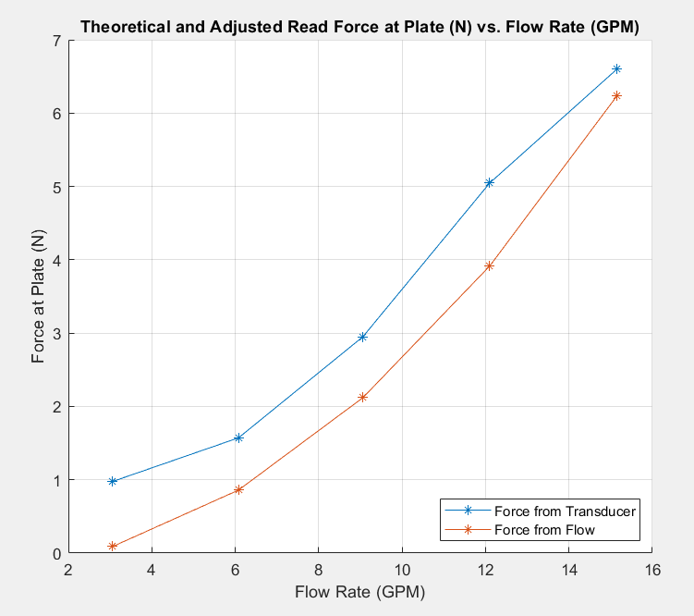
Figure 2. Flow Rate (GPM) vs. Theoretical and Read Forces at Plate (N)

This data shows that the calculated force is consistently lower than those read via the transducer. In fact, there seems to be a present constant shift in the data between each of these sets of forces. This shift exacerbates the percent error between these values, which is calculated assuming the adjusted read values are correct. The percent errors are found in the table below:

Table 5. Percent Error (%) from Forces for Different Flow Settings (%)
Flow Setting (%) | Theoretical Force (N) | Adjusted Read Force (N) | Percent Difference (%)
20 | 0.088693 | 0.97594 | 90.912
40 | 0.85951 | 1.572 | 45.324
60 | 2.1197 | 2.951 | 28.169
80 | 3.9141 | 5.0461 | 22.433
100 | 6.2397 | 6.6029 | 5.5006

Because the shift seems to be a constant value, this clearly has a large impact on the lower flows where the measured and calculated forces are much lower, meaning the constant shift is of a larger percentage of the data it is impacting.
To allow further discussion of error, the zero flow loads were also run to see what effect the weight of the plate has on the load cell when alone. This data can be seen below:

Table 6. Flow (GPM) and Transducer Force (lbf) Averages from Readout of Zero-Flow Condition
Flow Setting (%) | Flow Rate (GPM) | Flow Rate Std. Dev. (GPM) | Transducer Force (lbf) | Transducer Force Std. Dev. (lbf)
0 | 0.005 | 0.0070711 | 1.33 | 0
0 | 0.002 | 0.010328 | 1.14 | 2.3406e-16

Looking at this data, it appears as if the plate after the experimentation is of a lower weight. If instead this weight is applied to Eqn. 5 instead of deriving the weight of the plate by its supposed mass and gravity, the following adjusted read data is instead obtained:
Table 7. Adjusted Read Forces (N) for Different Plate Weight at Different Flow Settings (%)
Flow Setting (%) | Adjusted Read Force (N) | Adjusted Read Std. Dev. (N)
20 | 0.13345 | 1.0411e-15
40 | 0.72951 | 0.022971
60 | 2.1085 | 0.022971
80 | 4.2036 | 0.023444
100 | 5.7604 | 0.023444

When graphing this data, it appears that this set of read data pairs much more closely to the theoretical, calculated flows:

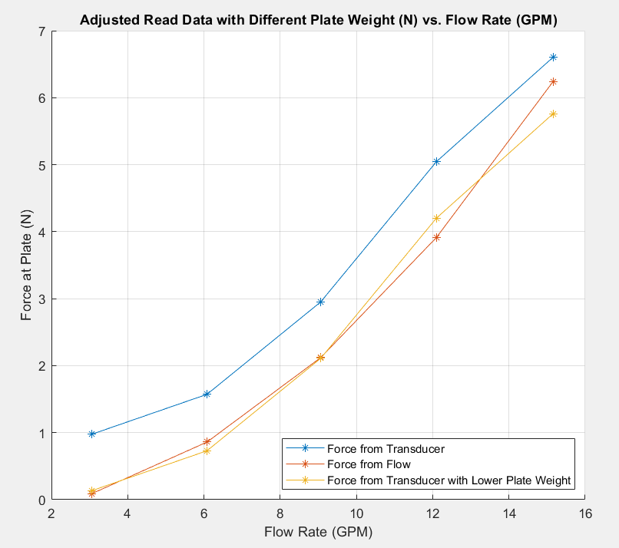
Figure 3. Adjusted Read Data with Different Plate Weight (N) vs. Flow Rate (GPM)

- CONCLUSIONS
To reiterate, the purpose of this lab was to validate the conservation of linear momentum concept. After gathering and analyzing the data, the calculated, theoretical forces seem to follow the same trend as the adjusted transducer forces (adjusted, meaning shifted by the plate weight to provide the impingement force), though due seem to be off by a somewhat constant value. This constant value places the transducer readings significantly higher than the theoretical, calculated flows. This is evident in the percent errors, where the constant shift applied to smaller values produced a much larger percent error. One potential reason for this being off by a constant value would result from the constant shift that is applied to the transducer readings: the weight of the plate. When looking at the zero-flow conditions for the transducer force readings before and after experimentation, the value of the weight of the plate seems to decrease in value. One potential explanation for this odd phenomenon would be if there was water resting on top of the plate from some previous experimentation that was expelled during this lab. This would make the initial reading higher than the actual weight of the plate, which would then be shown more accurately after the lab in the same zero-flow condition. If the latter force load is used as the weight of the plate (converted to newtons), new adjusted read force values are obtained. When graphing these values over the theoretical data, they are clearly much closer in value, as the trend lines nearly overlap entirely. This would back up this potential error case that the reported mass values are incorrect and that the mass of the plate at the start of the experiment was higher than what it should have been.
Another source of error in the experiment is only observed visually. When just looking at the numbers, it would be near impossible to determine. For the lower flow conditions, it is possible for jet of water to not produce enough velocity to send the water outwards in a complete horizontal velocity. This leads to water dripping from the plate early and pulling the plate down, or not impacting the plate well at all, with both these scenarios heavily affecting load cell data. This phenomenon can be seen in the following figure comparing a high flow case to a low flow case:
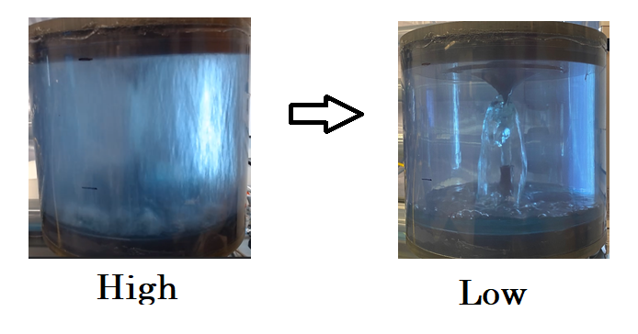
Figure 4. Comparison of High Flow Case to Low Flow Case

Again, this emphasizes the percent error seen at the lower flows, showing that the lower flow rates (20% and 40%) should likely not be used in consideration. However, looking at the remaining data points, the linear momentum conservation concept seems to be backed up by this system. Besides the shifted error likely arising from plate weight, there is room for error in the momentum itself. It is unlikely that every drop of water moved perfectly in the horizontal plane after impacting the plate. This would lead to not all the vertical linear momentum being transferred to the plate. It is also equally unlikely that the water jet is perfectly split evenly in all directions on the horizontal plane, meaning some of the water jet’s force is consumed in the horizontal plane. In other words, the force applied is not entirely vertical.
Overall, the results of this experiment are not terrible with all considerations. There is clearly some error in the system, possibly from the weight of the actual impingement plate. In addition, the fluid interaction is not entirely ideal, leading to a lack of total vertical momentum transition between the fluid and the plate. However, when looking at the higher flows with the adjusted read data readings of the lower plate weight, the data seems to match somewhat well, especially at higher flow rates. In both cases, the data sets seem to follow the same trend, emphasizing the concept of linear momentum conservation.

- REFERENCES
[1] Rajab Yassen, Saeed. (2019). 3D CFD Simulation and Experimental Study of a Water Jet Impingement. Kufa Journal of Engineering. 10. 53-65. 10.30572/2018/KJE/100405.
[2] Mechanical Engineering Department. “Lab 4 Linear Momentum Video Slides” Iowa State University. 13 April 2021

APPENDIX A: Calculations
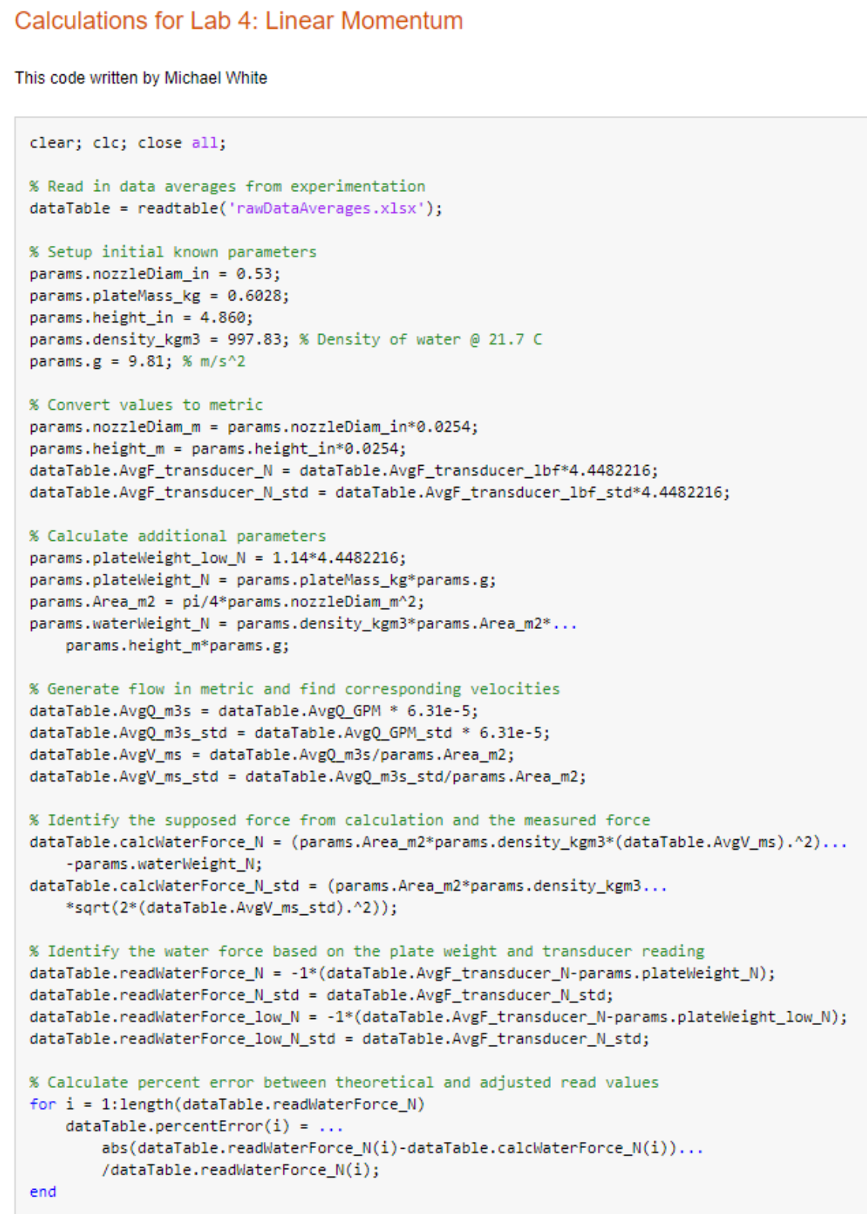
APPENDIX A: Calculations (cont.) 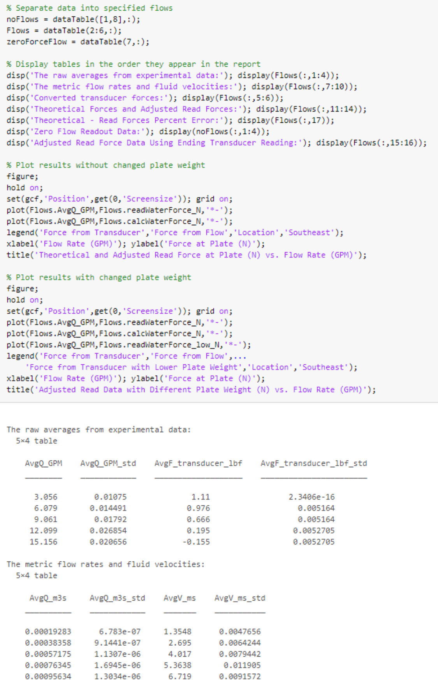
APPENDIX A: Calculations (cont.)
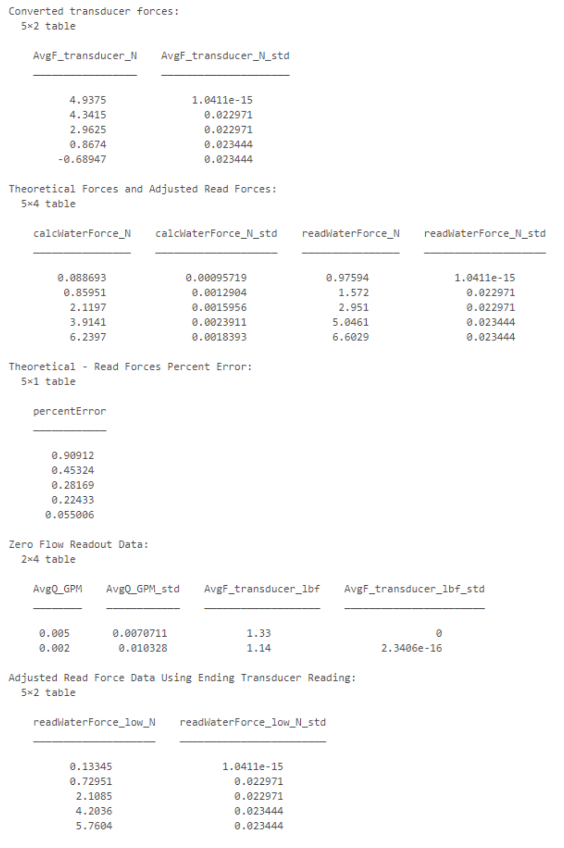
APPENDIX A: Calculations (cont.)
